PROGRAMMING FUNDAMENTALS
Assignment


ROLL NO:
25109

SECTION:
MORNING(B)

COURSE CODE:
CSC-300

SUBMITTED BY:
HOORAIN FATIMA

SUBMITTED TO:
MAM SADIA SAHER

DEPARTMENT OF COMPUTER SCIENCE
GOVERNMENT COLLEGE WOMEN UNIVERSITY FAISALABAD

Question # 1

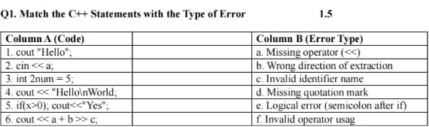
Answer:
1-a
2-b
3-c
4-d
5-e
6-f

Question # 2
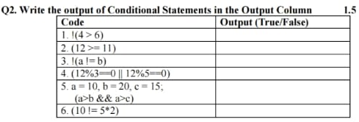
Answer:
- False
- True
- True
- True
- False
- False

Question # 3
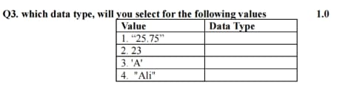
Answer:
- String
- Int
- Char
- String

Question # 4
- int main() {
cout << "Hello\tWorld\n";
cout << "C++\\Program\nming";
cout << "C++\bProgramm\bing";
}
Output:
Hello World
C++\Program
mingC+Programing
- int main() {
int a = 10, b = 4;
cout << a % b;
}
Output:
2
- int main() {
int x = 3;
x = x + 4;
cout << x + 2;
}
Output:
9
- int main() {
int a = 2.3;
cout << a;
}
Output:
2
- int main() {
int x = 3, y = 4, z = 5;
if (x > y)
z += x;
else if (y > z)
z = z - y;
else
z = z + 2;
cout << z;
}
Output:
7
- int main() {
int age;
cout << "Enter age: ";
cin >> age;
cout << "Your age is " << age;
return 0;
}
Output:
Enter age: Your age is 21
- int main() {
if (a > 5)
cout << "A";
cout << "B";
}
Output:
Eroor

- int main() {
int x = 2, y = 3, z = 4;
cout << x + y * z / x;
}
Output:
8
- int main() {
int a = 5, b = 10;
cout << (a > b ? a : b);
}
Output:
10
- int main() {
int x = 2, y = 3;
cout << ( (x + 1 * y + 1) + (y - 1) );
}
Output:
8
- int main()(float Irate 10.5; cout<<irate;)
Output:
10.5

- int main()( if (a=5) (cout << "Five";}}
Output:
Five
(Explanation: assignment a 5 yields non-zero true. Note: as shown this requires a declared; otherwise it's a compile error.)

- int main(){ int a; cout << a;)

Output:
Indeterminate/garbage value (uninitialized variable undefined behaviour)

- int main(){ cout << "She said "Hello"";}
Output:
Compile-time error (incorrect nested quotes-must escape inner quotes or use 17

- int main(){ int = 5; }
Output:
Compile-time error (missing variable name)

- int main(){ int num = "5"; }
Output:
Compile-time error (cannot assign string literal to int)

- int main()(cout << "Area"; cout << 3.14*r*r;}
Output:
Compile-time error (identifier r is undefined/undeclared)

- int main()( if (x > 0) { cout << "Positive";}}
Output:
Depends on x. If x is declared and >0 Positive. As written (no declaration) compile error/undeclared variable.
- int main(){ cin << number; if (number 10) cout << "Equal"; }
Output:
Two issues: cin << number; is wrong operator (should be cin >> number;). If corrected and user inputs 10 prints Equal; otherwise prints nothing.

- int main()(if (x <5&& x>2) cout << "Range":)
Output:
Prints Range when x is greater than 2 and less than 5 (i.e. 3 or 4 for integer x). Otherwise nothing. (If x not declared compile error.)

- int main(){ int result = 10/2*;)
Output:
Compile-time error (incomplete expression/syntax error)

- int main(){ cout <<1+4>>7; }
Output:
0
(Explanation: 1+4>> 7 is evaluated as (1+4) >>7+5 >>7+0.)

- int main()( cout << "Path: C:\newfolder"; }
Output:
Path: C:
ewfolder
(Explanation: \n is an escape for newline- so C:\newfolder becomes C: then newline then ewfolder.)

Q5- Short question answers (1-14)

- Difference between cin and cout in C++

cin reads input from standard input (keyboard) into variables (uses extraction >>), cout writes output to standard output (screen) using insertion <<.

- What happens if user inputs wrong data type using cin?

cin fails and sets the stream into a fail state (cin.fail() becomes true). The variable is not assigned properly; subsequent I/O is ignored until the error state is cleared (e.g., cin.clear() and flushing the bad input). This can lead to unexpected behavior.

- Differentiate between float and double

Both store floating-point numbers. float is typically 32-bit (#7 decimal digits precision). double is typically 64-bit (#15 decimal digits precision) - more precise and preferred for most calculations.

- What happens if you use an uninitialized variable in an expression?

Behavior is undefined. For built-in types, it typically yields an indeterminate/garbage value and may produce unpredictable results or runtime bugs.

- What is an escape sequence in C++ and why is it needed?

An escape sequence starts with followed by a character (e.g., \n, \t, \", \\). It represents special characters inside string/character literals (newline, tab, quote, backslash). Needed to embed those non-printable or reserved characters safely inside strings.

- Why not just press Enter inside a string to create a new line instead of using \n?

String literals cannot contain raw unescaped newline characters (it would break the literal across lines and cause a compile error). Use \n or string concatenation or raw string literals (R"(multi-line)") to create line breaks.

- Purpose of the modulus (%) operator

% gives the remainder of integer division. Example: 7% 31. Useful for parity tests (n %
2), cyclic indexing, etc.

- Can else be used without preceding if? Explain.

No. else must follow an if (or else if) and is attached to the nearest unmatched if. Using else alone is a syntax error.

- Can else be used without preceding if? Explain.

No. else must follow an if (or else if) and is attached to the nearest unmatched if. Using else alone is a syntax error.

- What happens if you end an if condition with a semicolon?

if (cond); /..../) means the if controls an empty statement (the semicolon). The block that follows executes unconditionally. This is usually a logical bug.

- Difference between and = operators

= is the assignment operator (stores right-hand value into left-hand variable). == is the equality comparison operator (tests whether two values are equal, returns true/false).

- Can you combine multiple relational conditions in one expression? Give example.

Yes-using logical operators &&, ||, !. Example: if (x > 0 &&x10) (...) (true when x is between 1 and 9).

- What happens when operators have the same precedence?

If operators have the same precedence, evaluation order is determined by associativity (left-to-right or right-to-left). For example, a-b-cis (ab) c (left-associative).

- General syntax of the ternary operator and its components

Syntax: condition? expression_if true: expression_if_false
It evaluates condition; if true it yields expression_if_true, otherwise expression_if_false.
Often used as a short if-else for value selection.

- Naming rules for identifiers in C++

Must start with a letter (A-Z, a-z) or underscore (cannot start with a digit).
After first character may contain letters, digits, or underscores.
No spaces or punctuation.
Cannot use C++ reserved keywords (like int, for, class, etc.).
Identifiers are case-sensitive (Value value).

Q6-C++ program

Here is a simple, correct C++ program that implements the requested behavior:

#include <iostream>
using namespace std;

int main() {
int year;
cout << "Enter year: ";

if (!(cin >> year)) {
cout << "Invalid input\n";
return 0;
}

if (year >= 2000 && year <= 2015) {
int sum = 2000 + 2015;
cout << "Year is between 2000 and 2015 (inclusive).\n";
cout << "Sum of 2000 and 2015 = " << sum << '\n';
}
else if (year >= 2016 && year <= 2025) {
int sum = 2016 + 2025;
cout << "Year is between 2016 and 2025 (inclusive).\n";
cout << "Sum of 2016 and 2025 = " << sum << "\n";
}
else {
cout << "Year is not in the range.\n";
return 0;
}

return 0;
}

